Ninth Sunday After Pentecost
July 25, 2021
When Jesus held a picnic, people came by the thousands. The disciples’ "Food Committee" dropped the ball, and Jesus once again saved the day. Like the disciples of Jesus’ day, we are still unable to adequately make provision for our need, but Jesus is here to meet our need. Have you come prepared for the picnic…or for the feast that Jesus is here to provide for us today?
******************************************************
The Church Gathers

Please listen in silence to the music of the Lord.
Prelude: “Give Me Jesus” Arr: Bethany K. Smith
Sharing Our Joys: Please say your Prayer Requests at this time.
God’s Welcome
Preparing For Worship:

To Affirm Its Faith
Introit: Piano
Call To Worship:
Liturgist: Why have you come to this place?
People: We have come to find Jesus.
Liturgist: Why have you come today?
People: We are tired in body and spirit.
Liturgist: Jesus bids you sit and be at ease.
People: We are hungry with nothing to eat.
Liturgist: Come and eat your fill.
People: But there are only five barley loaves and two fish.
Liturgist: There is plenty for all.
People: Will we find wholeness here?
Liturgist: Jesus gathers the fragments of our lives that nothing
may be lost.
Invocation:
Opening Hymn: “God is My Strong Salvation" #373
Reading Of The Psalms: Psalm 145:10-18
Call To Confession:
Prayer Of Confession: (Unison) Father in heaven, from deep within, we know we have failed to live as Your people should live, in the love of Christ. Have mercy on us, O God! Pour out the rich blessing of the grace of your forgiveness on our parched souls. Feed us with Heaven’s Bread, so we might be nourished by Your gentleness. Shape us as Your people, and restore us to faithful living, as we seek to follow our Lord and Savior, Jesus Christ, in whose name we make our humble prayer. Amen.
Assurance of Pardon:
Special Music: “Why Me Lord?”
Soloist: Gary Loll
Offertory Sentence:
Receiving Our Tithes and Gifts:
Offertory: “Offertory Piece" Robert Lau
*Doxology: (515)
*Prayer of Thanksgiving:

To Hear the Word

Epistler Lesson: Ephesians 3:14-21
*Gospel Lesson: John 6:1-21
*Gloria Patri: (513)
Hymn Of Illumination: “Dear Lord and Father of Mankind” #341
Message: "...That Through the Church" Rev. Miller
Pastoral Prayer:
Lord’s Prayer: (Sins-Sin)

To Respond to the Word

*Closing Hymn: “Savior, Again to Thy Dear Name” #60
*Benediction:
*Postlude: “All Hail the Power of Jesus’ Name" Arr: Janet Vogt

Pastor: Rev. Tim Miller
Organist and Choir Director: Ralph W. Farrar
Liturgist: Jerry Steves
Ushers: Bill Hazenberg
Scripture Reader: Gary Loll
Parish Nurse: Doris Landy (716-763-7793)

Announcements

Worship Service 10:00am

Upcoming Events

August 8: Communion. The loose offering will go to the Deaconry Fund.

August 13: (Friday) Church Dinner at Shawbucks at 6:00pm

August 15: Church Picnic at the Allen Park Men’s Club at 11:00am.

Our website is: www.pilgrimmemorialucc.org
Please join us on Facebook at pilgrimfirstucc.
We extend a warm welcome to our guests and visitors.

The People of the United Church of Christ in Jamestown
Welcome You

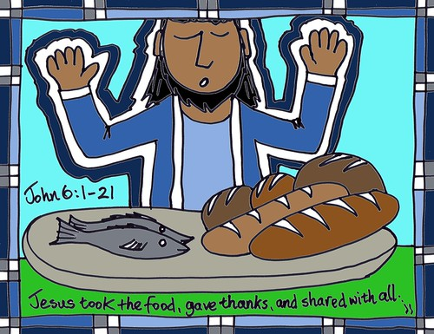

Ministers: Each one in the congregation made up of First Congregational Church and Pilgrim Memorial Church

