Eighteenth Sunday After Pentecost
September 26, 2021
In response to the attempt by His disciples to stop a man from casting out demons in his name, Jesus teaches the necessity of embracing and empowering outsiders to the community to be insiders. The essence of discipleship involves not the control of others, but following Jesus’ model of including all who seek to follow Him.

The Church Gathers

Please listen in silence to the music of the Lord.
Prelude: “Diapason Voluntary” Gordon Young
Sharing Our Joys: Please say your Prayer Requests at this time.
God’s Welcome
Preparing For Worship:

To Affirm Its Faith
Introit: Choir
Call To Worship:
Liturgist: Jesus has touched our lives, and now we are
responsible for sharing our faith.
People: Each Christian becomes a teacher to interpret
God's love and will to others.
Liturgist: To neglect that is to lead someone astray, and Jesus
gave a very serious warning against that.
People: May we be firm in our faith, and true in our witness
as we represent Christ in our world.
Invocation:
Opening Hymn: “Eternal Father, Strong To Save” #429
Reading Of The Psalms: Psalm 19:7-14
Call To Confession:
Prayer Of Confession: (Unison): We would not want anyone to lose his faith because of our negligence, or because of our misleading them, Father. But so often we do not feel responsible for the witness we give through our lifestyle. Forgive us if we have been the cause of someone’s believing wrong to be right. Keep us always conscious of those who look to us for our example to follow, that we may lead them to Christ, through whom we pray. Amen.
Choral Response:
Assurance of Pardon:
Anthem: “Create In Me A Clean Heart, O God” Carl. F. Mueller
Offertory Sentence:
Receiving Our Tithes and Gifts:
Offertory: “Andante” W. A. Mozart
*Doxology: (515)
*Prayer of Thanksgiving:
Mission Moment: Peg Frankiewicz

To Hear the Word

Epistle Lesson: James 5:13-20
*Gospel Lesson: Mark 9:38-50
*Gloria Patri: (513)
Hymn Of Illumination: “Lord, Speak To Me, That I May Speak” #397
Message: “Extreme Measures” Rev. Miller
Pastoral Prayer:
Lord’s Prayer: (Sins-Sin)

To Respond to the Word

*Closing Hymn: “I Would be True” #489
*Benediction:
*Postlude: "Triumphal March" G. F. Handel

Pastor: Rev. Tim Miller (716-345-9150)
Organist and Choir Director: Ralph W. Farrar
Liturgist: Jerry Steves
Ushers: Bill Hazenberg and Gary Carnes
Scripture Reader: Gary Loll
Parish Nurse: Doris Landy (716-763-7793)

Announcements

Worship Service 10:45am
Thursdays: Choir Practice at 7:00pm

Today’s special offering is for the Hurricane Ida victims.

Women’s Group meets after church today.

Zion Covenant Church has sent us an invitation to their “Becoming the Beloved Community" workshop on October 2. The morning session addresses cultural awareness, and the afternoon session deals with racial righteousness. Lunch will be provided for $10. Please read the insert. Pastor Tim will be attending.

Diane Nelson came closest to guessing the number of candies in our jar. She guessed 310, and there were 287.

If you wish to meet with Pastor Tim, you may call him or text him at 716-345-9150. He is usually available to meet weekdays between 2:30 and 5:00pm or for lunch at the Allen Street Diner.

Upcoming Events

Next Sunday: Oct. 3 is our Neighbors In Need Special Mission Offering.
Thursday, October 7: Bible Study at 1:00pm

We have several activities coming up and need everyone’s participation: 1) We will need candy and cars for Trunk or Treat to be held on October 24 from 5:30-6:30pm and volunteers to help inside with the free coffee, hot chocolate and donuts. 2) Once again we will have our clothesline for winter hats, mittens, gloves, scarves, warm socks and footies. Please give your donations to Peg or Diane. 3) The Women’s Group will be having a Basket Raffle in November. More information will follow after the group meets Sept. 26.

Our website is: www.pilgrimmemorialucc.org
Please join us on Facebook at pilgrimfirstucc.
We extend a warm welcome to our guests and visitors.

The People of the United Church of Christ in Jamestown
Welcome You

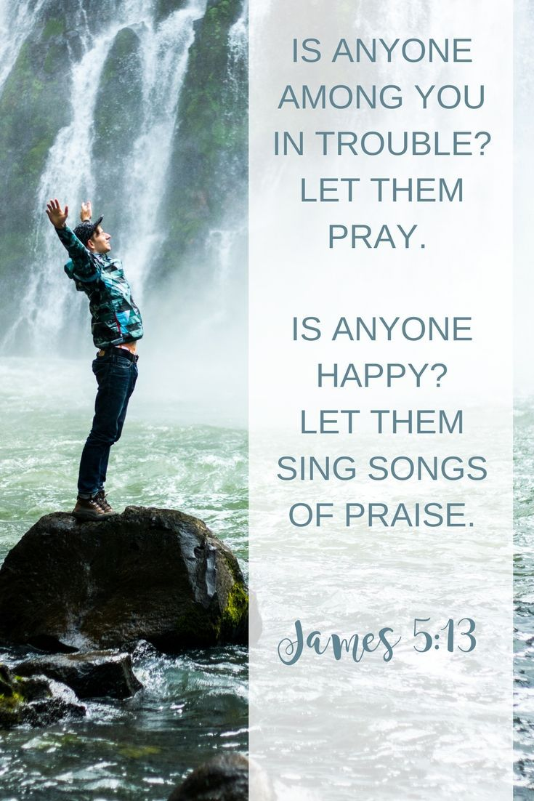

Ministers: Each one in the congregation made up of First Congregational Church and Pilgrim Memorial Church

