Sixth Sunday of Easter
May 22, 2022
Like the man in our Gospel today, all of us come to a place in our lives from time to time where we need to make a change. This man said he wanted change, but others always seemed to get ahead of him, get in his way. After 38 years of this, his discouragement must have been very real. But Jesus told him if he wanted to experience change, he had to "get up" and take his mat. It wasn’t until he participated in the change that he experienced change. Real change demands our involvement.

The Church Gathers

Please listen in silence to the music of the Lord.
Prelude:
Sharing Our Joys: Please say your Prayer Requests at this time.
God’s Welcome
Preparing For Worship:

To Affirm Its Faith
Introit: Choir
Call To Worship:
Liturgist: Jesus said, “This is my commandment, that you love
one another."
People: By this time, everyone will know that we are
Christ's disciples.
Liturgist: With the help of God, let us love one another,
People: Because love is from God, and we are from God.
Liturgist: We are called into this vision from God, to love one
another.
People: Because God loved us so much, He sent His only
Son for us.
Liturgist: Let us join our hearts in worship.
People: Let God's love be perfected in us. Amen!
Invocation:
*Opening Hymn: “The Church's One Foundation" #260
Reading Of The Psalms: Psalm 67
Call To Confession:
Prayer Of Confession: (Unison) Life-giving Spirit, we confess that our vision is narrow. We are shot-sided in our love for one another and even in our love for ourselves. Call us out of our shells to recognize the wonders of Your creation and our brothers and sisters around us. Cal us out of the tunnels of tasks and to-do lists into the fullness of life that You have given us. In the name of Jesus, our Guide on this journey of faith, we pray. Amen.
Choral Response:
Assurance of Pardon:
Anthem:
Offertory Sentence:
Receiving Our Tithes and Gifts:
Offertory:
*Doxology: (515)
*Prayer of Thanksgiving:

To Hear the Word

Book Of Acts: Acts 16:9-15
Second Reading: Revelation 21:10, 22-22:5
*Gospel Lesson: John 5:1-9
*Gloria Patri: (513)
Hymn Of Illumination: “Breathe On Me, Breath Of God" #234
Message: “Some People Ask The Dumbest Questions" Pastor Tim
Pastoral Prayer:
Lord’s Prayer: (Sins-Sin)

To Respond to the Word

*Closing Hymn: “O For A Thousand Tongues To Sing" #223
*Benediction:
*Postlude:

Speaker: Rev. Tim Miller
Organist and Choir Director: Ralph W. Farrar
Liturgist: Jerry Steves
Ushers: Bill Hazenberg and Gary Carnes
Scripture Reader: Donald Nelson
Parish Nurse: Doris Landy (716-763-7793)

Announcements

Worship Service 10:45am
Thursdays: Bible Study at 1:30pm
Thursdays: Choir Practice at 7:00pm

Thank you, Tim, for returning to lead us today.

Board meeting and Coffee Hour after church.

Women’s Group meets today after the Board Meeting.

LOOKING AHEAD

Friday, June 10 the church dinner will be at the Olive Garden. Signup sheet is on the back table.

Our website is: www.pilgrimmemorialucc.org
Please join us on Facebook at pilgrimfirstucc.
We extend a warm welcome to our guests and visitors.

The People of the United Church of Christ in Jamestown
Welcome You

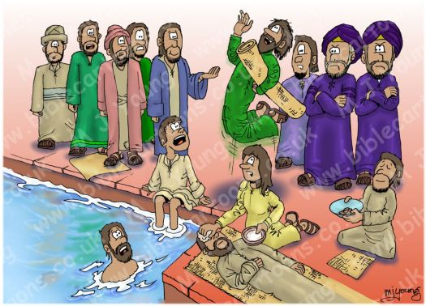

Ministers: Each one in the congregation made up of First Congregational Church and Pilgrim Memorial Church

